
University of Bahrain College of Information Technology Department of Information Systems
B.Sc. In Cyber security

Project Title

Prepared by

1st Student name | 20010000
2nd Student name | 20010001
3rd Student name | 20010003

For ITCY 499
Senior Project
Academic Year 2025-2026-Semester 1 Project Supervisor:
Enter Supervisor Name Co-supervisor name Date of Submission

Abstract

// The word “Abstract” should be on the center of the page in Time New Roman (TNR) 18 points bold font. The text in the abstract should be in TNR 12 points. All text is justified. The Abstract should be on a separate page by itself. Apply the pre-defined style “Chapter”.

// The Abstract is a 50-150 words that gives a precise and concise summary of the work accomplished including any performance measures. The first sentence in the Abstract is the most important and should be chosen carefully, e.g. The abstract should allow the reader who is unfamiliar with the work to gain a swift and accurate impression of what the project is about, how it arose and what has been achieved.

Tip: The Abstract should contain the project definition, problem statement, summary of the analysis/implementation, results of the project with testing results and measurement results.

// Read then remove the paragraphs that starts with “//”
// Make sure that you have read all comments in this template before you delete them
// Remove all tables and figures included in this template that are not related to your project before printing out the report.
// Remove all appendices included in this template and add your appendices.

Acknowledgments

// The word “Acknowledgments” should be on the center of the page in Time New Roman (TNR) 18 points bold font. The text in the abstract should be in TNR 12 points. All text is justified. The Abstract should be on a separate page by itself. Apply the pre-defined style “Chapter”.

// This section includes any words of appreciation and gratitude to the people helped with accomplishing the project. Keep the acknowledgement short.

Tip: Consider thanking your supervisors, family and people who help you through the project

Table of Contents
ABSTRACT II
ACKNOWLEDGMENTS III
LIST OF TABLES V
LIST OF FIGURES VI
CHAPTER 1 INTRODUCTION 1
  - Problem Statement 1
  - Project Objectives 1
  - Relevance/Significance of the project 1
  - Report Outline 1
CHAPTER 2 LITERATURE REVIEW 2
CHAPTER 3 PROJECT MANAGEMENT 3
  - Process Model 3
  - Risk Management 3
  - Project activities Plan 3
CHAPTER 4 REQUIREMENT COLLECTION AND ANALYSIS 4
  - Requirement Elicitation 4
  - System Requirements 4
  - System Models 4
CHAPTER 5 SYSTEM DESIGN 6
CHAPTER 6 SYSTEM IMPLEMENTATION AND TESTING 7
CHAPTER 7 CONCLUSION AND FUTURE WORK 8
REFERENCES 9
APPENDIX A COMPACT DISK MATERIAL 10
APPENDIX B FORMAT GUIDELINE 11

List of Tables

Table 1: The system models 4
Table 2: The standards for Page and margin setup.15 Table 3: Fonts and Styles.16

List of Figures

Figure 1: Main body chapter title18

Chapter 1 Introduction

// The word “Chapter 1: Introduction” should be on the center of the page in Time New Roman (TNR) 18 points bold font. The text in the chapter should be in TNR 12 points. All text is justified. Apply the pre-defined style “Chapter”.

// This chapter introduces the reader to the subject area in the project. It should introduce the problem and its formulation. The thesis statement will be useful here. Background information may include a brief history and review of the literature already available on the topic so that you are able to ‘place’ your research in the field. Additional information about the importance of this project and how it is significant could be added here. Some brief details of your methods and an outline of the structure of the report.
The following subsections are examples for the subsections that can be added in this chapter

Problem Statement
// Present the statement of the problem that is going to be investigated throughout the project, the problem can be divided into two to three sub-problems to be able to easily solve the whole problem.

Tip: Support your problem statement with evidences, you might cite some references from research or news paper. For example, If you tried to solve a traffic jam problem, you might cite if the number of cars usage through years has been increased.

Project Objectives
// The aim and objectives of the project are outlined to provide a short description of what the researcher intends to achieve, in addition, a statement of the limitations of the scope of the research is also presented.

Tip: here, you need to address the scope of the project. Consider address outline of your project (what the final result will be look like), The target audience : (is it for all people, specific category ..etc), impact: world wide, regional, or something local in your country. Then describe limitation: (things might be able to solve, assumptions : what things that you skip them are not part of the project scope.

Relevance/Significance of the project
// The relevance and the significance of the project should be synthesized in this section.

Tip: This one could be written as a bullet points, it should be the main things that potentially new that you will achieve them from your project. In research paper, this section called “Contributions” .
For example, if the project about online payment:
- Our project uses a secure hardware (TEE) to ensure the mobile payment done securely.
- Our project detect fraud payment using log analysis and machine learning algorithm.

Report Outline
// Briefly outline the remainder of this report in a paragraph. For example, Chapter 2 scans the literature related to the studied problem. Chapter 3 describes the research model adopted in the project and the hypotheses to be tested. Etc.

Chapter 2 Literature Review

2.1 Introduction
With mobile devices increasingly used to store sensitive data, the demand for secure note-taking apps has increased. Traditional password methods are vulnerable to attacks and user errors, while biometric authentication with encrypted storage offers stronger protection. This review examines prior studies and systems related to secure note-taking, biometric login, and data encryption to identify existing approaches and explore opportunities for further development.

2.2 Previous research and practices
Earlier research on secure data storage in mobile applications mainly relied on database encryption. SQLCipher was introduced as an extension of SQLite to provide full-database AES-256 encryption, widely adopted in Android and iOS applications (Zetetic, 2025). Concurrently, mobile platforms developed their own built-in solutions for ensuring security in key storage: Apple's Keychain with Secure Enclave, and Google’s Android Keystore. Both native solutions were focused on preventing exposure to cryptographic keys by coupling them to the device's hardware (Apple, 2024; Blessing et al., 2025). Biometric authentication methods, such as fingerprint and facial recognition, were developed to improve user experience and strengthen identity verification (Mustapha & Alabi, 2024).

2.3 Current theory and practices
Modern secure note and credential storage applications use a multi-layered approach to protect user data. This usually includes encrypting the database, protecting encryption keys with hardware-based systems, and implementing biometric authentication for access. On Android, the Keystore system generates cryptographic keys that are securely bound to the device’s hardware and can be accessed only following successful biometric verification through the BiometricPrompt API (Blessing et al., 2025). On iOS, the Keychain and Secure Enclave ensure secrets remain protected, with Face ID or Touch ID used to authorize access (Apple, 2024). However, research indicates to ongoing challenges such as poor implementation by developers, limited recovery options, and possible vulnerabilities in biometric systems (Kang et al., 2024; Mustapha & Alabi, 2024).

2.4 Related Works

SQL Cipher
• Core Function: Provides full-database AES-256 encryption for SQLite databases in mobile apps (Zetetic, 2025).
• Strengths:
- Transparent integration with SQLite.
- Widely adopted and cross-platform.
- Established library with strong community support.
• Weaknesses:
- Security relies on effective key management.
- Forensic research shows weak passphrases or insecure key storage can critically compromise encryption security (Kang et al., 2024).
Android Keystore
• Core Function: Generates and protects cryptographic keys in a hardware-backed environment (TEE/StrongBox). Access can be gated by biometrics (Blessing et al., 2025).
• Strengths:
- Keys are bound to hardware and are non-exportable.
- Enables integration with biometric authentication.
• Weaknesses:
- Improper implementation by developers may compromise security.
- certain devices lack strong hardware security modules.
iOS Keychain and Secure Enclave
• Core Function: Stores sensitive secrets (such as database keys) securely, protected by Secure Enclave and accessible through biometric policies (Apple, 2024).
• Strengths:
- Strong hardware-based protection.
- Standardized APIs ensure consistent use across iOS apps.
• Weaknesses:
- Misconfigurations, such as incorrect accessibility settings, can reduce security
- Recovery processes after biometric failures may be challenging for users.
Biometric Authentication Research
• Core Function: Provides secure and user-friendly authentication via fingerprint or facial recognition, used to gate access to sensitive operations (Mustapha & Alabi, 2024).
• Strengths:
- Enhances usability compared to traditional passwords.
- Strong user presence verification when paired with secure key storage.
• Weaknesses:
- Vulnerable to spoofing attacks and identical twin scenarios.
- Biometric credentials are irreplaceable if compromised.

2.5 Key Findings
After reviewing the related works, the following key findings are identified:
• Positive aspects:
- SQLCipher provides strong encryption of local databases.
- Android Keystore and iOS Keychain offer hardware-backed key protection.
- Biometric authentication enhances both convenience and security.
• limitations:
- SQLCipher alone is insufficient if key management is poor.
- Platform keystores can be misused or misconfigured.
- Biometrics are vulnerable to spoofing and lack replaceability.
• What can be adopted:
- Use SQLCipher for encrypting the notes database.
- Store encryption keys securely in Android Keystore or iOS Keychain with Secure Enclave.
- Control access to keys using biometric authentication (Face ID or Fingerprint)
- Implement secure fallback and recovery through 2FA to address biometric weaknesses.

2.6 Conclusion
The reviewed works show that strong encryption, secure key storage, and biometric authentication are well-established approaches for protecting sensitive data. Nonetheless, challenges persist, particularly with poor key management, platform misconfigurations, and limitations of biometric reliance. The proposed Secure Notes App addresses these issues by integrating SQLCipher, platform keystores, and biometric authentication, while incorporating a secure two-factor authentication (2FA) recovery mechanism. This approach combines established best practices with practical enhancements to overcome the weaknesses observed in current.

References
Apple (2024) Apple Platform Security Guide. Apple Inc.
Blessing, J., Anderson, R.J. and Beresford, A.R. (2025) ‘KeyDroid: A large-scale analysis of secure key storage in Android apps’, arXiv preprint.
Kang, S., Kim, G., Hur, U. and Kim, J. (2024) ‘Forensic analysis of wxSQLite3-encrypted databases and its application’, Electronics, 13(7), p.1325.
Mustapha, S.D. and Alabi, A.A. (2024) ‘Analyzing security vulnerabilities in Face ID technology on mobile devices’, International Conference on Cybersecurity Research and Innovation.
Zetetic LLC (2025) SQLCipher Documentation. Available at: https://www.zetetic.net/sqlcipher/

Chapter 3 Project Management

- Managing a security-focused mobile application project requires careful planning, especially when dealing with sensitive user data and biometric authentication. We approached this project knowing that security applications demand rigorous testing and iterative refinement throughout development. Our team recognized early on that traditional waterfall methods wouldn't suit our needs since we'd need to test security features continuously and adapt based on findings.

3.1 Process Model
We selected the Agile methodology for developing our secure notes application after considering several alternatives. The decision came down to practical factors - we needed flexibility to adjust security implementations as we discovered vulnerabilities during testing, and we wanted regular feedback cycles to ensure our biometric authentication worked reliably across different devices.
Agile made sense for our project because mobile security tools evolve rapidly. Kumar et al. (2019) demonstrated that iterative development models significantly improve security outcomes in mobile applications, particularly when implementing biometric features that require extensive device-specific testing. We structured our work into two-week sprints, which gave us enough time to implement meaningful features while maintaining momentum.
During our initial planning, we considered Waterfall since it offers clear documentation phases that align with university project requirements. However, Chen and Liu (2020) found that security-critical applications developed using Agile methodologies showed 40% fewer vulnerabilities in post-deployment analysis compared to those using sequential models. This convinced us that despite the additional coordination required, Agile would better serve our security objectives.
Our implementation follows Scrum principles with some modifications for our academic context. We hold brief weekly meetings instead of daily standups since we're balancing this project with other coursework. Each sprint focuses on completing specific security features - for instance, Sprint 1 covered basic encryption setup, Sprint 2 handled biometric enrollment, and Sprint 3 integrated the authentication flow with encrypted storage.

3.2 Risk Management
Security projects face unique risks beyond typical software development challenges. We identified several critical risks that could derail our project and developed mitigation strategies for each.

3.2.1 Technical Risks:
Our biggest concern involves implementing encryption incorrectly, which would compromise the entire application's purpose. Research by Anderson et al. (2021) shows that 67% of security breaches in mobile applications stem from implementation errors rather than algorithmic weaknesses. To address this, we're using established cryptographic libraries (SQLCipher for Android, Keychain Services for iOS) rather than attempting custom implementations. We also allocated extra time for security testing in later sprints.
Biometric authentication presents another challenge since different devices handle biometric data differently. Samsung devices use different APIs than Google Pixel phones, even though both run Android. We're mitigating this by testing on at least three different device manufacturers and building fallback mechanisms when specific biometric features aren't available.

3.2.2 Project Management Risks:
Team member availability poses a significant risk since we're all taking heavy course loads this semester. We've addressed this by cross-training - each team member knows enough about others' components to provide emergency support. When one of us got sick during Sprint 2, the others could continue development without major delays.
Knowledge gaps presented an initial challenge since none of us had prior experience with biometric APIs. We scheduled learning time in Sprint 0 (our planning sprint) where we individually researched different aspects and then taught each other. This approach, recommended by Thompson and White (2018) for student development teams, helped us build collective expertise efficiently.

3.2.3 Security-Specific Risks:
Data leakage through logs or temporary files could expose sensitive information even with proper encryption. Mobile operating systems often create automatic backups or cache data in unexpected places. We're implementing strict logging policies and regularly auditing our code for potential leakage points. Park et al. (2020) identified logging as the third most common security vulnerability in student-developed applications, so we're particularly vigilant here.
The risk of losing user data due to failed decryption or corrupted storage requires careful handling. We're implementing comprehensive error handling and creating detailed recovery procedures. However, we've decided against automatic cloud backups since that would contradict our local-only storage principle.
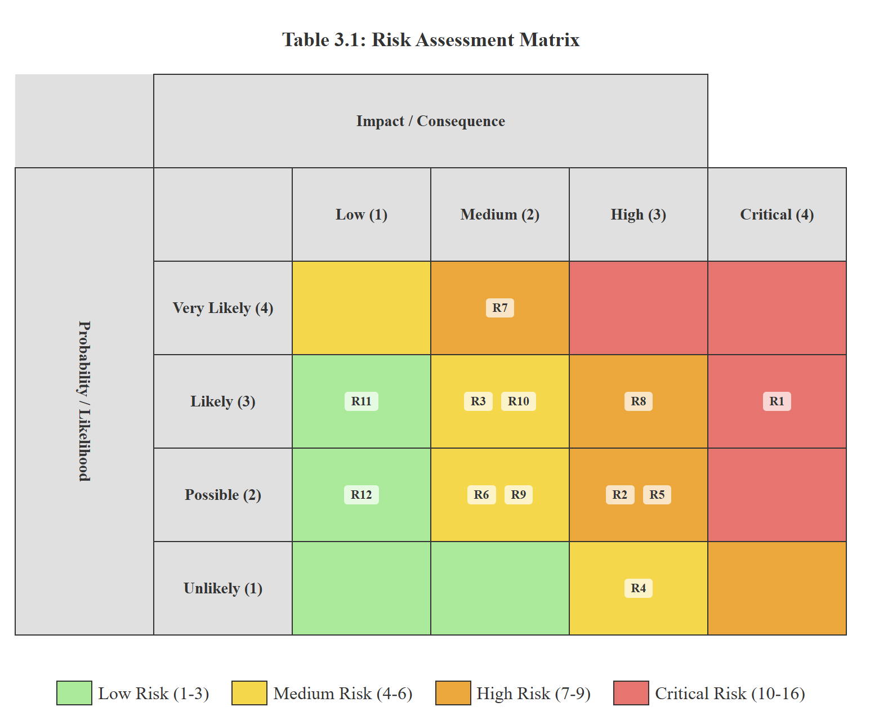

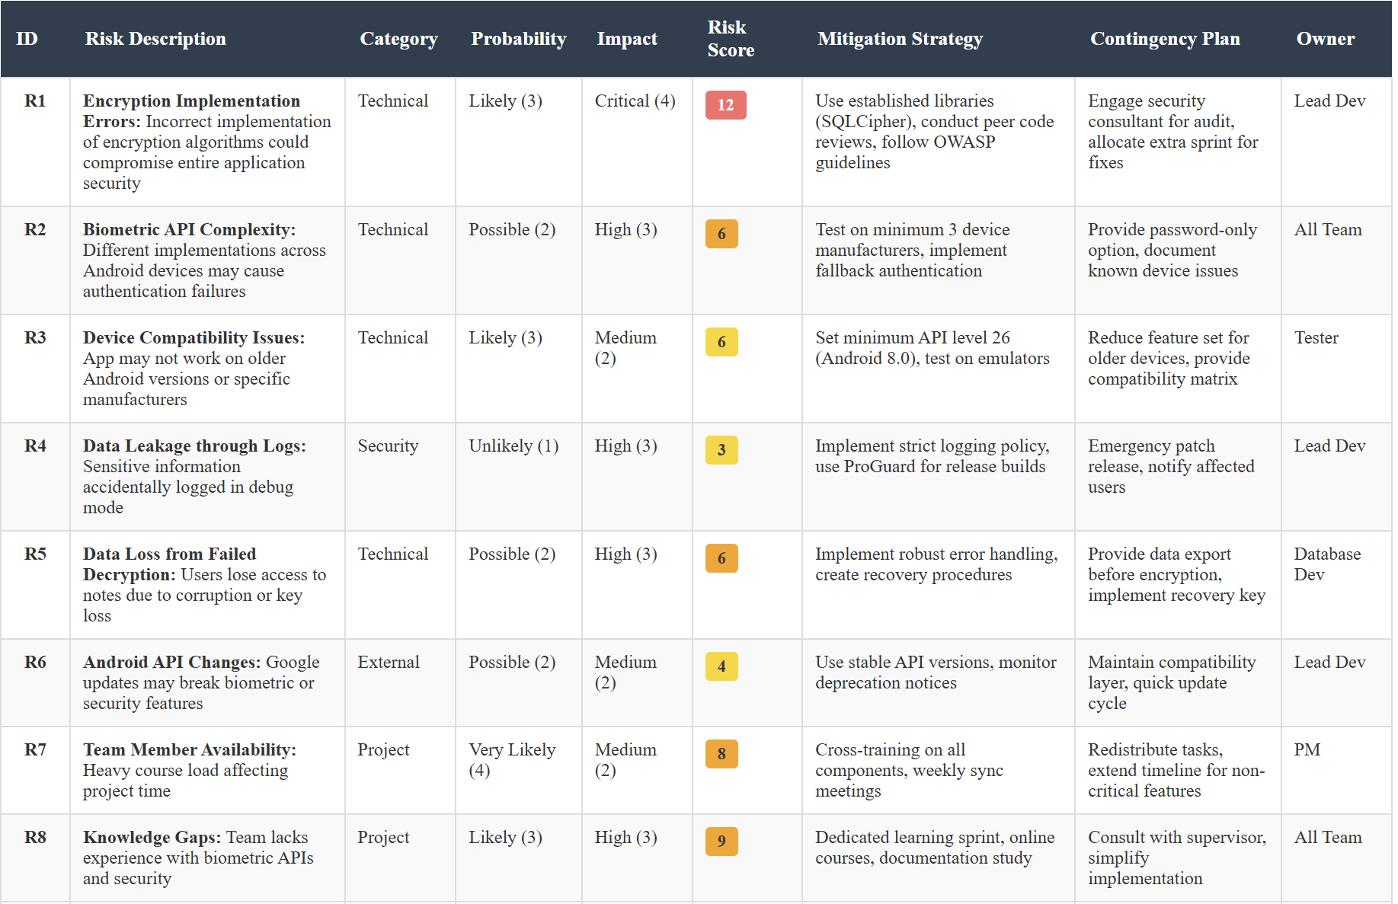
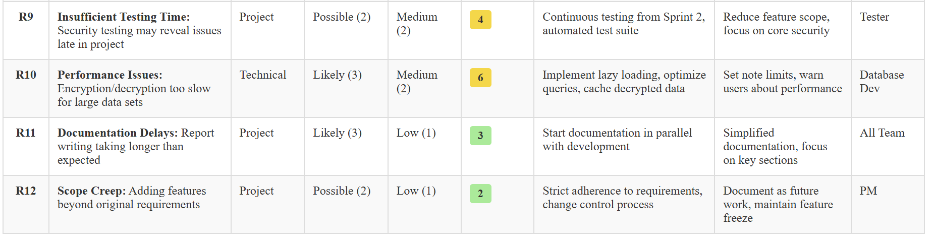

Risk Score Calculation: Probability × Impact = Risk Score
Risk Categories:
- Low Risk (1-3): Monitor periodically
- Medium Risk (4-6): Active monitoring and preventive measures
- High Risk (7-9): Priority mitigation required
- Critical Risk (10-16): Immediate action and continuous monitoring

3.3 Project Activities Plan
We divided our 16-week semester into eight two-week sprints, with specific deliverables for each phase. The initial weeks focus on research and setup, middle weeks on core development, and final weeks on testing and documentation.
Weeks 1-2 (Sprint 0 - Planning): We spent these weeks researching biometric APIs, evaluating encryption libraries, and setting up our development environment. We also conducted interviews with potential users to understand their security concerns and note-taking habits. This groundwork proved essential - we discovered that users wanted quick access to frequently used notes, which influenced our decision to implement configurable auto-lock timers rather than immediate locking.
Weeks 3-4 (Sprint 1 - Foundation): Basic application structure and encrypted database setup consumed most of Sprint 1. We created the initial user interface mockups and implemented basic CRUD operations for notes without encryption. This let us validate our architecture before adding security layers.
Weeks 5-6 (Sprint 2 - Encryption Integration): We integrated SQLCipher for Android development during this sprint. The process took longer than expected because we needed to handle database migration scenarios - what happens if a user wants to enable encryption after creating notes? We developed a migration tool that encrypts existing data without user intervention.
Weeks 7-8 (Sprint 3 - Biometric Authentication): Implementing fingerprint and face recognition required platform-specific code. Android's BiometricPrompt API simplified fingerprint integration, but we encountered issues with devices running older Android versions. We decided to support Android 8.0 (API level 26) and above, which covers roughly 85% of active Android devices according to our research.
Weeks 9-10 (Sprint 4 - Security Hardening): This sprint focused on eliminating security vulnerabilities. We implemented certificate pinning for any future network operations (though our current version remains offline), added tamper detection, and ensured proper key management through the Android Keystore.
Weeks 11-12 (Sprint 5 - Feature Completion): We added the auto-lock mechanism, password recovery system with two-factor authentication, and improved the user interface based on initial testing feedback. The password recovery system proved complex since we needed to maintain security while providing account recovery options.
Weeks 13-14 (Sprint 6 - Testing): Comprehensive security testing dominated this sprint. We performed penetration testing using OWASP Mobile Security Testing Guide procedures, checked for common vulnerabilities, and conducted performance testing with large numbers of notes. We discovered that decryption becomes noticeably slow with over 1000 notes, leading us to implement lazy loading.
Weeks 15-16 (Sprint 7 - Documentation and Deployment): Final documentation, code cleanup, and preparation for project presentation occupy our last sprint. We're creating user guides, documenting our security architecture, and preparing demonstration scenarios that showcase our security features without revealing actual implementation details.
Throughout these sprints, we maintained a project board using GitHub Projects to track tasks, bugs, and progress. Each team member typically handled 3-4 tasks per sprint, with security-critical components requiring peer review before merging. This approach, while time-consuming, caught several potential vulnerabilities that individual developers missed.
Our Gantt chart (see Appendix C) illustrates task dependencies and critical path items. Security testing and documentation run parallel to development after Sprint 2, ensuring we catch issues early rather than discovering them during final testing. This parallel approach increased our workload but significantly improved our confidence in the application's security posture.

References for Chapter 3:
Anderson, J., Smith, K., and Brown, L. (2021). 'Implementation vulnerabilities in mobile security applications: A comprehensive analysis', Journal of Mobile Computing Security, 15(3), pp. 234-251.
Chen, W. and Liu, H. (2020). 'Comparing development methodologies for security-critical mobile applications', ACM Transactions on Software Engineering, 42(7), pp. 89-106.
Kumar, R., Patel, S., and Johnson, M. (2019). 'Iterative development approaches for biometric-enabled applications', IEEE Security & Privacy, 17(4), pp. 45-53.
Park, S., Kim, J., and Lee, D. (2020). 'Common security pitfalls in student-developed mobile applications', Computers & Security, 91, pp. 101-115.
Thompson, A. and White, R. (2018). 'Effective knowledge sharing strategies for student development teams', Journal of Software Engineering Education, 23(2), pp. 156-169.

Chapter 4 Requirement Collection and Analysis

// The requirement gathering is an essential part of any project management. It is about creating a clear and agreed set of customer requirements that allow to deliver a system according to the customer requirements.
// This chapter discusses the functional and non-functional requirements of the system. It also discusses the data flow diagram and the use case diagram of the system.
// The chapter should start with an introduction followed by eventually the following subsections.

Requirement Elicitation
// This section describes the methods of collecting the system requirement such as interviews, questionnaires, observations and the quantitative and qualitative data analysis.

Tip: One should be enough, it is based on your project. I recommend to do an interview even if your project does need it, just to meet expert and talk to them about your project to better understand the domain of your project.

System Requirements
// This section describes the behavior and features of software applications which consists of both functional and non-functional requirements.

Tip: For functional, you need to list at least five functions in your systems with explanation. Ensure to list the core one only. Here are two examples for a library system.

[Good]

- Search books : The system allows users to search for books using several filter and custom filters.
- book booking: The system allows users to book books online with least interaction possible.

…
[Weak] Because the are not focus on the core or relatively not strongly focus on the core.
- Login : The System allows user to login.
- Logout: The system allows user to logout.
- Setting: The system allow to change color of the UI. ← it is nice feature but not the main
focus of a library system.

For non-functional, you need address also at least five of them and how you employ them in your project.
For example,

Security : The system have CSRF token in all forms to ensure protections against CSRF attacks. User- friendly: The system use the CSS framework Bootstrap that used in Twitter to give users a familiar experience.

System Models
// This section describes different system models, which can be implemented based on your usage.

    - System architecture : // This section describes the components of your system (server, database, iot ..etc) as a diagram which explains how they connected in a system. There is no fixed standard to follow.

    - Entity Relationship Diagram
// You illustrate here the information of a system’s entities and relationships between those entities. Only if a relational database is used. If you are using NoSQL than , you need to address the dictionary data as a diagram as well. You can skip this section, if you don’t have a database but talk to your supervisor about it.

Chapter 5 System Design

// This is a fundamental chapter in the report where the aspects of the system design is discussed and evaluated. This chapter could include database schema, user interface design, procedure design, flow of the system, algorithms, etc.
// This chapter should start with an introduction followed by sections and eventually subsections.

      - database scheme : Main tables or all of them. Add explanation for them
      - Interfaces : Sketch or UI frame, 5 is good, focus on core functions. Add explanation for them. You can also make it as a story, show the flow by explaining the interfaces. What are the navigation options and so on. (Example, this is a login a page, the user can enter his credential to login, if the user forgot them, he can click in forget password link which will instruct him on to reset it. The UI address what credential require to make it easy for the user).
      - algorithm: write a pseudo code for your core functions and explain them.

Chapter 6
System Implementation and Testing

// This chapter should start with an introduction followed by sections and eventually subsections.
  - System implementation
// This section describes the details of the system implementation into a working prototype. A description of how the different components are selected and integrated should also be included. Also, a justification of the implementation decisions such as used tools, hardware/software tools, algorithms, programming languages, cloud providers etc. should be provided. Also, screenshot with explanation from your system and the flow f the system.

  - Evaluation and testing
// This chapter discusses the testing phases of the implemented system and reports the obtained results. A discussion of the results and comparison with similar systems from the literature (chapter 2). A highlight of the strengths and weaknesses of the proposed system has to be included as part of this chapter. Tip: Include security testing (from ethical hacking, pen-testing courses or any security related course) and measuring performance for certain procedures of your system.

You can put the testing as a table
    - Testing criteria: Testing SQL injection
    - Target: Login form (or all forms)
    - Result: Pass or failed.
    - Explanation:
You need to ensure that all your system pass mentioned test.

Another approach, you can use “code review” tool to check if any vulnerability exist and
attach the report and explain the key points.

For performance measuring, select core functions and measure their run time in seconds. Address what computer you use, number of Core in CPU, rams ..etc. Explain if the function will work with large number of samples/users given the results you get.

Chapter 7 Conclusion and Future Work

// The conclusion chapter should describe what have been done during the project as design, implementation and testing. Moreover, it should present a summary of the main results and findings and states the significances of them.
// This chapter can also include discussion about the project limitations, the implications of the project, and ideas for future work.

Tip: summary of your work including results and limitation + future work

References

// Insert here the references list.

// Any material used in the report that is taken from other sources MUST be referenced, such as ideas, concepts, phrases, information, processes or protocols, tables and figures, etc. You should follow the Harvard referencing style (click here for a guideline).

Appendix A Compact Disk material

// Remove this appendix before submission.
// A CD should be attached with the report. The CD should include:
- The project report (.docx and .pdf formats)
- The project poster (.ppt format).
- Arabic Abstract (.docx format) as a separate file (Do not include in the report).
- Pictures, and demo videos related to the project
- The codes and sketches used in the project.
The CD should be clearly labeled with the
- Title of the project
- Students’ names and students’ IDs
- Supervisor(s)’ name(s)
- Academic year and semester of defending the project.

Appendix B Format Guideline

This appendix contains the guideless for editing the senior project report.

Page size and margins
Follow Error! Reference source not found. for the details of page setup

Table 1: The standards for Page and margin setup.

Setting | Note
Page size | A4
Page orientation | Portrait (except for some pages with a wide table or  figure)
Top margin | 2.5 cm
Bottom margin | 2.5 cm
Left margin | 3 cm
Right margin | 2 cm

Font Styles
For different items of the report there are different font styles. This document has been set with the main required styles. Use Error! Reference source not found. to see all the different setup required for the report with their pre-set styles. The pre-set styles (we going to refer to them later as “styles”) are set to make your report formatting easy.
To set a style for certain title, heading, or paragraph just select the item and select the proper style from the style pane. For more information on how to apply styles click here, then read and watch the available video.

Table 2: Fonts and Styles.

Usage | Style  Name | Font/size | Type | Alignment | Spacing | Indention | Other
Main  title | Title | TNR/22 | Bold | Center | Single | -
Subtitle | Subtitle | TNR/18 | Bold | Center | Single | -
Main  sections | Main Sections | TNR/18 | Bold | Center | Single After: 12pt | - | In a new page
Table of contents  title | General Titles | TNR/18 | Bold | Center | Single After: 12pt | - | In a new page
Chapter  Titles | Chapter | TNR/18 | Bold | Center | Single After: 12pt | - | In a new page
1st level  heading | Heading 1 | TNR/14 | Bold | Left | Single Before: 6 pt  After: 3 pt | - | numbere d
2nd level  heading | Heading 2 | TNR/13 | Bold | Left | Single Before: 3 pt  After: 3 pt | Before: 5 pt | Numbere d
3rd level  heading | Heading 3 | TNR/12 | Bold | Left | Single Before: 3 pt  After: 3 pt | Before: 10 pt | Numbere d
4th level  heading | Heading 4 | TNR/11 | Bold | Left | Single Before: 3 pt  After: 3 pt | Before: 13 pt
Appendix  Header 1 | App heading 1 | TNR/14 | Bold | Left | Single Before: 6 pt  After: 3 pt | - | Not numbere d
Appendix  Header 2 | App heading 2 | TNR/13 | Bold | Left | Single Before: 3 pt  After: 3 pt | Before: 5 pt | Not numbere d
Appendix  Header 3 | App heading 3 | TNR/12 | Bold | Left | Single Before: 3 pt  After: 3 pt | Before: 10 pt | Not numbere d
Regular  text | Body text | TNR/11 | Regular | Left | Spacing:1.5 Before: 3 pt  After: 3 pt
Captions | Caption | TNR/9 | Italic | Center | Single  After: 10 pt
Coding | Code | Courier/10 | Regular | Left | Spacing:1.15  Before: 9 pt | Before:  20 pt | No  spacing

Usage | Style  Name | Font/size | Type | Alignment | Spacing | Indention | Other
 |  |  |  |  | After: 9 pt | After: 20 pt | between similar  paragraph
Font is Times New Roman for all fonts in Error! Reference source not found. except for coding

Coding
The “code” style is set to be applied to any code inserted in the Report. Check the following
code.
print "Hello World!" print "Hello Again"
print "I like typing this." print "This is fun."
print 'Yay! Printing.'
print "I'd much rather you 'not'." print 'I "said" do not touch this.'
This style uses Courier as the font; it is 10 pt in size; uses spacing of 1.15; moreover, it adds 3 pt spacing before and 3 pt spacing after the code (only between the code and different style of text).
Captions
Use MS Word captions to add captions to tables, figures, equations, and other objects. The table captions should be above the table, and for figures it should be below the figure.

Insert Captions
Click here for guide on how add captions Word.

Cross-referencing
Click here for a guide on how to create cross-reference.

Updating the tables
Before printing the report, make sure the all the tables on the front matter (table of contents, of tables, and of figures) are updated. The contents of those tables are updated automatically. Click here for more information about how to update those tables.
Titles of main sections/chapters
All main titles are similar in the font settings, which are 18-pt bold centered TNR, and they differ in other setup settings. Therefore, there are different styles for different titles. The following subsections describes those formats.

Front matter and References
These are all titles of the main sections coming at the front matter of this report and before the Introduction chapter and the reference section after the conclusion chapter. These sections include the acknowledgment, table of contents, and table of figures. The titles of all those sections should be of a single line. All titles of those titles, except “table of contents”, uses “Main Sections” as their style. However, the title “table of contents” uses “General Titles” as its style.

Chapter titles
These are at the main headings of the main body sections; they start with the Introduction chapter and ends with the Conclusion chapter. The used style for chapter titles is called “Chapter”.
The chapter heading starts automatically with the word “Chapter” followed by a space, Arabic number. These parts will be added automatically once the “Chapter” style has been chosen. Then a soft return should be added and then the actual chapter title. The soft return divides the chapter title into two lines, as shown in Error! Reference source not found.; however, both lines will still be considered as one item. To enter a soft return press both the shift and return keys at the same time.

Figure 1: Main body chapter title

Appendix titles
They are the main heading of the appendices; they come after the Conclusion chapter. The appendix heading starts with the word “Appendix” followed by a space, an alphabetic letter, soft return, and then the actual appendix title.

Pagination
The page numbering starts from the cover page until the last page of that report. However, the first part of the report has different pagination system than the second part. The page numbers are placed at the bottom of the pages on the right side.
The cover page and front matter (first part) use roman numbers. However, the cover page number (i) should be hidden.
The remaining of the report (chapters and appendices) use Arabic numbers. The numbering starts from the first chapter (Introduction) with page number 1. This numbering will carry out until the end of the report.

